HR Workforce Attrition Analysis Report

Executive Summary
Employee attrition is a critical challenge that impacts organizational productivity, operational stability, employee morale, and recruitment costs. This report presents a workforce attrition analysis framework designed to identify employee turnover patterns, understand the drivers of attrition, and provide actionable recommendations for improving retention.

1. Business Problem
The organization has experienced a significant increase in employee turnover, creating operational disruptions and increasing recruitment expenses.
Key concerns include:
- Rising attrition rates
- Loss of experienced employees
- Reduced productivity
- Increased hiring and training costs
- Difficulty maintaining workforce stability
The HR department requires an analytical solution that identifies the root causes of employee attrition and highlights high-risk employee groups.

2. Project Objectives
The primary objectives of this analysis are:
- Measure workforce health using HR KPIs
- Analyze employee attrition patterns
- Identify factors influencing employee exits
- Segment employees based on retention risk
- Provide actionable recommendations for improving retention
- Develop an interactive dashboard for HR decision-making

3. Dataset Overview
The workforce dataset contains employee-related information such as:

Employee Information
- Employee ID
- Age
- Gender
- Department
- Job Role
- Education
- Marital Status

Employment Information
- Monthly Income
- Years at Company
- Total Working Years
- Overtime Status
- Business Travel

Employee Experience Metrics
- Job Satisfaction
- Environment Satisfaction
- Work-Life Balance
- Performance Rating

Attrition Information
- Attrition Status (Yes/No)

4. Data Preparation
The following preprocessing steps were performed:

Data Cleaning
- Removed duplicate records
- Handled missing values
- Standardized categorical variables
- Verified data consistency

Feature Engineering

Salary Band
- Low Salary
- Medium Salary
- High Salary

Experience Group
- Fresher (0–3 Years)
- Mid-Level (4–10 Years)
- Senior (10+ Years)

Retention Risk Score
High-risk employees were identified using:
- Low Job Satisfaction
- Low Work-Life Balance
- Frequent Overtime
- Low Income Levels
Risk Categories:
- Low Risk
- Medium Risk
- High Risk

5. Key Performance Indicators (KPIs)

Workforce KPIs
KPI | Description
Total Employees | Total workforce size
Attrition Rate | Employees who left ÷ Total Employees
Retention Rate | Employees retained ÷ Total Employees
Average Employee Tenure | Mean years at company
Job Satisfaction Score | Average satisfaction rating
Average Monthly Income | Mean employee income
Overtime Percentage | Employees working overtime
High-Risk Employee Count | Employees flagged as high risk

6. Attrition Analysis

Department vs Attrition

Key Findings
- Sales and customer-facing departments generally show higher attrition.
- Technical and R&D teams exhibit moderate attrition levels.
- Administrative departments show lower turnover rates.

Interpretation
High-pressure environments and performance-driven roles contribute to increased employee exits.
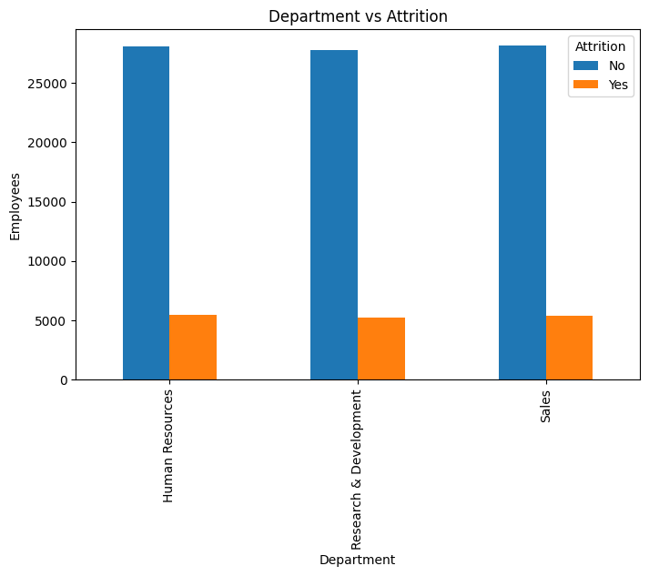

Salary vs Attrition

Key Findings
- Employees in lower salary bands experience significantly higher attrition.
- Attrition decreases as compensation increases.

Interpretation
Compensation competitiveness strongly influences employee retention.
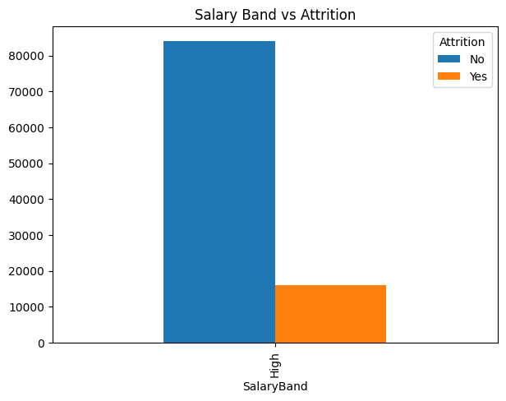

Work-Life Balance vs Attrition

Key Findings
- Employees reporting poor work-life balance are more likely to leave.
- Better work-life balance scores correlate with stronger retention.

Interpretation
Flexible work policies and workload management play a crucial role in retention.
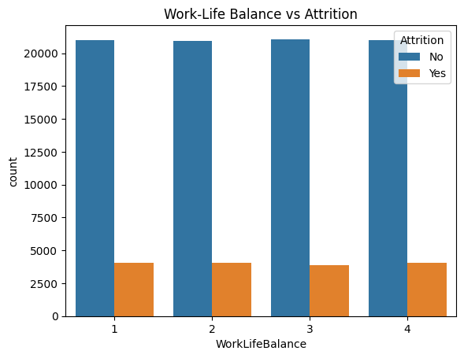

Overtime vs Attrition

Key Findings
- Employees working frequent overtime exhibit higher attrition rates.
- Long working hours increase burnout risk.

Interpretation
Workload distribution and staffing adequacy should be reviewed.
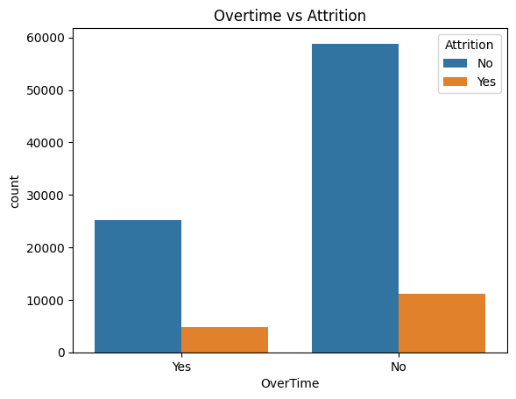

Job Satisfaction vs Attrition

Key Findings
- Low satisfaction employees contribute disproportionately to attrition.
- High satisfaction employees demonstrate significantly better retention.

Interpretation
Employee engagement initiatives can directly reduce turnover.
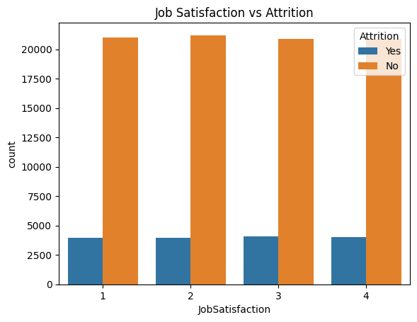

7. Employee Segmentation Analysis

High-Risk Employees
Characteristics:
- Low satisfaction
- Frequent overtime
- Low work-life balance
- Lower compensation
Recommended Action:
- Immediate retention interventions
- Managerial reviews
- Career development discussions

High Performers
Characteristics:
- Strong performance ratings
- High productivity
- Valuable organizational knowledge
Recommended Action:
- Recognition programs
- Leadership development opportunities
- Succession planning

Long-Term Employees
Characteristics:
- Extended tenure
- Strong institutional knowledge
Recommended Action:
- Retention incentives
- Mentorship opportunities

Overtime Employees
Characteristics:
- Consistently high workload
- Elevated burnout risk
Recommended Action:
- Resource reallocation
- Workforce planning improvements

8. Dashboard Structure

Executive Overview Dashboard
Displays:
- Total Employees
- Attrition Rate
- Retention Rate
- Average Tenure
- Satisfaction Score
- High-Risk Employees
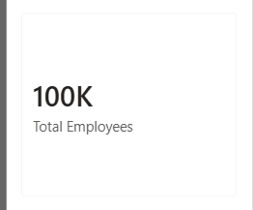

Workforce Dashboard
Displays:
- Department Distribution
- Gender Distribution
- Experience Groups
- Employee Demographics
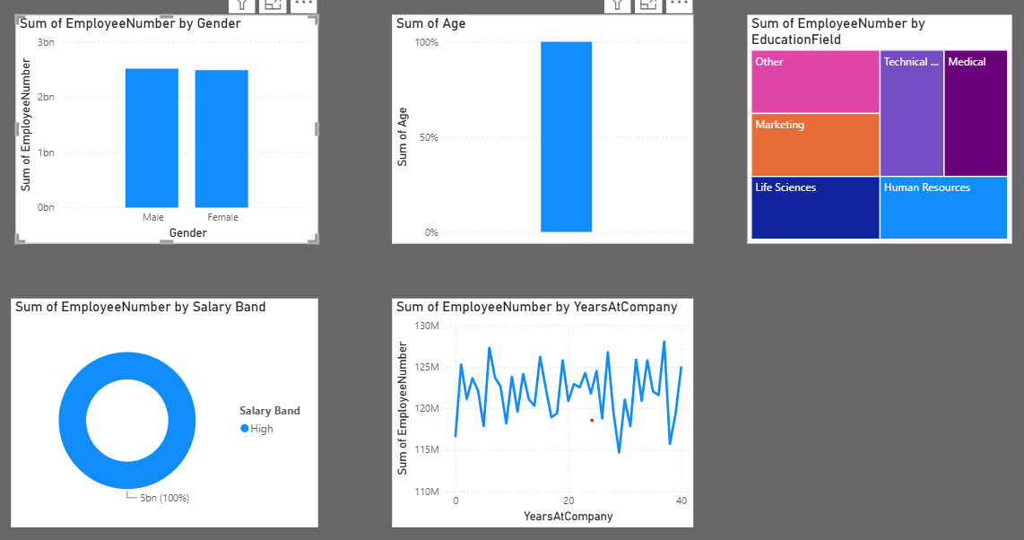

Attrition Dashboard
Displays:
- Attrition Trends
- Department Attrition
- Salary Impact Analysis
- Risk Segmentation

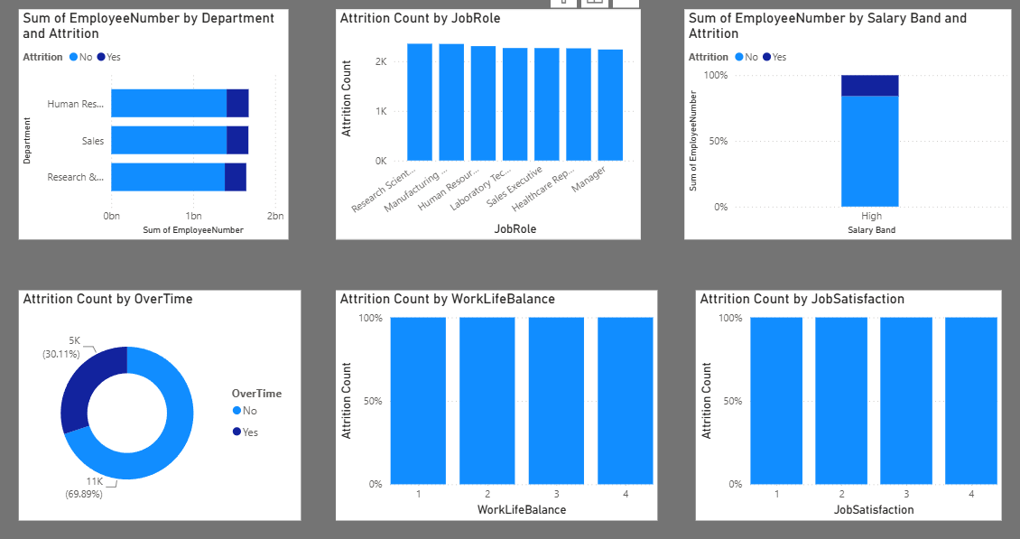

Employee Health Dashboard
Displays:
- Job Satisfaction
- Work-Life Balance
- Overtime Analysis
- Performance Metrics

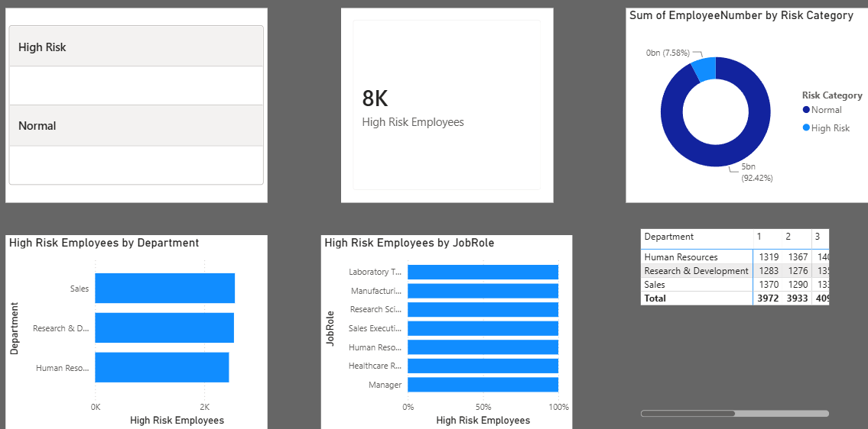

9. Business Recommendations

Recommendation 1: Reduce Overtime Dependency
- Improve workforce planning
- Balance workload distribution
- Monitor employee burnout indicators

Recommendation 2: Improve Compensation Strategy
- Benchmark salaries against industry standards
- Introduce performance-based rewards

Recommendation 3: Enhance Employee Engagement
- Conduct regular employee feedback surveys
- Implement recognition programs

Recommendation 4: Strengthen Career Development
- Create clear career progression paths
- Expand learning and development initiatives

Recommendation 5: Monitor High-Risk Employees
- Implement predictive attrition monitoring
- Conduct retention interview
Business questions
1. Which factors contribute most to attrition?
Answer: Employees who work overtime, have low job satisfaction, poor work-life balance, lower income, and fewer years at the company are more likely to leave.

2. Which departments have the highest employee turnover?
Answer: The department with the highest attrition rate has the greatest employee turnover. In most IBM HR attrition analyses, the Sales department tends to experience the highest turnover, followed by Research & Development.

3. How does work-life balance affect retention?
Answer: Employees with poor work-life balance are more likely to leave the company. Higher work-life balance scores are associated with better employee retention.

4. Which employees are at highest risk?
Answer: Employees at highest risk are those who:
- Work overtime frequently
- Have low job satisfaction
- Have poor work-life balance

5. What actions should HR leadership prioritize?
Answer:
- Reduce excessive overtime
- Improve employee satisfaction and engagement
- Enhance work-life balance initiatives
- Strengthen onboarding and support for new employees

10. Conclusion
Employee attrition is influenced by multiple interconnected factors including job satisfaction, compensation, work-life balance, and overtime workload. By leveraging workforce analytics and KPI-driven dashboards, HR leaders can proactively identify retention risks and implement targeted interventions.
The proposed HR Workforce Attrition Dashboard provides a comprehensive solution for monitoring workforce health, improving employee experience, and reducing future attrition.

Future Scope
- Predictive Attrition Modeling using Machine Learning
- Employee Sentiment Analysis
- Workforce Forecasting
- AI-Powered Retention Recommendations
- Real-Time HR Analytics Dashboard

